
DGMD E-28
Developing Single Page Web Applications
Midterm Project: Wordle

Summary
Utilize Javascript objects plus an API to create a one-page game app.
Task:
You are tasked with creating an app to implement the popular Wordle game (ref: https://www.nytimes.com/games/wordle/index.html)
Note that your implementation does not have to match the UI of NY Times version – the link is provided for reference.
Your submission will be judged on your ability to leverage Javascript objects within your design and to create an intuitive UI.
You are required to use one API in this app. You may use an API to choose the word to guess. Alternatively, you may use an API to check that the user’s guess is a valid word.
API’s must return JSON and must be accessed using XMLHttpRequest or a promise / fetch.
Note: You may not use React for this assignment. You may not research/copy code solutions for this assignment.

The board:
The screenshot is a model of how your implementation should appear. You are welcome to add enhancements as long as you meet the requirements. Note: Use an input box to enter the guess – this deviates from the NY Times version.
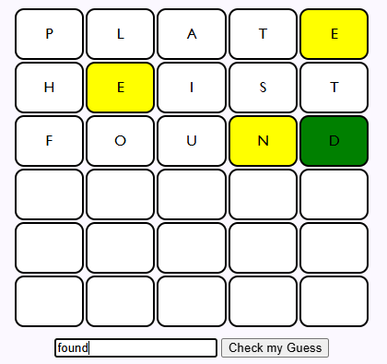

Used letter board:
You will need to display a used letter board indicating letters used. The used letter board must include a visual indicator of whether the used letter was correct/in the wrong place/ or not in the word. An example is shown below. Note, the color reflects “green” if any guess shows the letter in the right place.
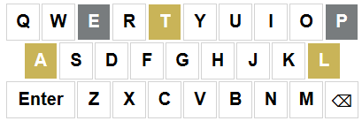

Game play:
The player has 6 tries to guess a 5 letter word.
Guesses must be 5 letter words (you will need to validate this)
For each letter in the guess, you must report one of three results:
if the letter is not in the answer (grey)
if the letter is in the answer but in a different place than in your guess word (yellow)
if the letter is in the same place as in the guess word (green)
Here is an example response:
Answer: PRIDE
Guess: DOPED
the D is in the wrong place
the O is not in the word
the P is in the wrong place
the E is in the wrong place
the second D is not in the word
The game ends when the user guesses the word or uses all 6 guesses.

Note: If a letter appears twice in the guess but only once in the answer, you must eliminate all possible yellow/green responses and then consider any repeat letters.
For example – if the answer is “create” and the guess is “tacit”
t is yellow
a is yellow
c is yellow
i is grey
t is grey

Required Features:
- Display a used letter board so that the user can avoid letters that have been eliminated.
- Include a “debug” mode that displays the answer in the console so that it is easier to check correct operation.
- Allows the user to play multiple games – i.e., you need to handle restarting the game.
- Responsive to tablet size (down to 700px)
- Comments must precede each function plus inline comments as appropriate
- Must work online

Optional Features:
- Track statistics of wins and losses- and how many guesses a win needed.
- Add some animation when the user wins.
- Other?

Additional features are encouraged once the requirements are met. Exceptional work and additional features will receive up to 10 points extra credit.

Rubric
Works to spec online 70%
Code plus UI quality 30%

Deliverables Worksheet

URL https://aebens.github.io/DGMD-E28/Assignment%204/index.html
[X] All code files uploaded

Did you complete any extra features?
I added a confetti canon and I made it so there are more games available beyond the game of the day. I also added the ability to submit with the enter key. I also have it keep focus on the input box after clicking submit so that you can have a keyboard only experience.
Was there anything you could not get to work?
I struggled for a longtime to get the API to work. I couldn’t find any that worked. I found the link to the NY Times endpoint on someone’s GitHub and verified that it is the word of the day. The CORS error took time to research and I realized it could be done in Postman. I did this to avoid more complicated solutions.
What was the API you used – and why (include the url to the source)
I am using Postman to handle the NYT endpoint [https://www.nytimes.com/svc/wordle/v2/{YYYY}-{MM}-{DD}.json] to avoid CORS error. The Postman URL is here:
https://cb47ec42-51bd-426b-9b32-7eb2d3ff5054.mock.pstmn.io/svc/wordle/v2/${today}.json

Reflection question:
What was the most satisfying part of this assignment, and why?
I do like the way that it looks at the end and that it does function. I could make more words in the set list and basically just abandon the NY Times list if I wanted to. It was very empowering to see how technically simple the game is, even if it did take a bit of time for me to figure out how things should work.

